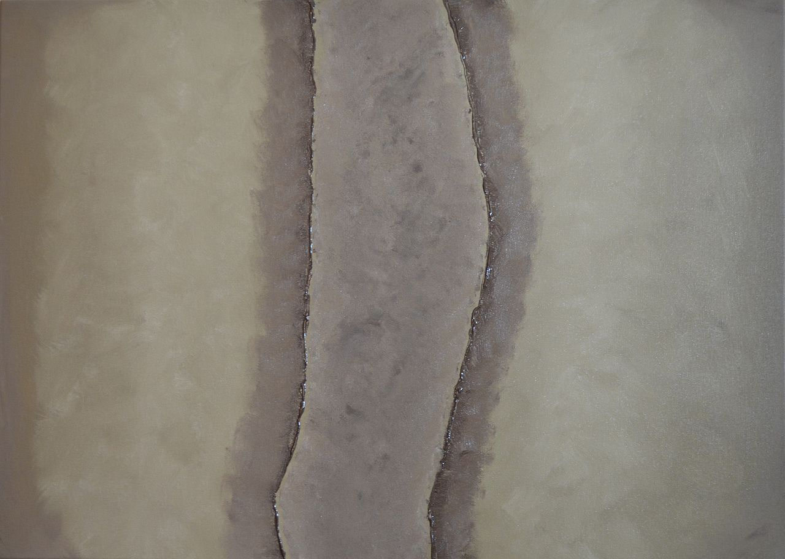

Gerald Sider

COLLEGE OF STATE ISLAND, CUNY

February 20. 2015

**2014-2015 Anthropology Colloquium Series**

**Ph.D. Program in Anthropology**

The Graduate Center | CUNY

Unless otherwise noted, colloquia take place **Fridays 4:15-6:00 PM** at the Graduate Center in room **C415A** (concourse level – one floor below the lobby), followed by receptions in the **Brockway Room** (room **6402** – 6th floor).

ETHNOGRAPHY

AND

TRAJECTORIES

OF STATE